Proposal Grp 1. P.3

Amanda Cantu, Jamie Hutton, Jodee Harris & David Rojas

We have chosen the topic of school shootings in the U.S. Analyzing the national data by creating a tool powered by a Python Flask API and includes HTML/CSS, JavaScript, and the chosen database. Considering the importance and urgency of addressing this issue, this tool is meant for public awareness.

The user will be able to interact by using drop down boxes by state. This tool will be able to filter by city and state. Map with drop downs for stats based on yearly records of school shootings in the entire country.

Datasets:

1. [data-school-shootings/school-shootings-data.csv at master · washingtonpost/data-school-shootings (github.com)](https://github.com/washingtonpost/data-school-shootings/blob/master/school-shootings-data.csv)
2. [Export Complete | Gun Violence Archive](https://www.gunviolencearchive.org/export-finished?filename=public%3A//export-1e134ef8-e4a6-45f9-992c-eed1a1befcdc.csv&uuid=99d3ff0d-76d2-4042-bf55-15417482432b&return_href=mass-shooting)
3. [School Shooting Data (kaggle.com)](https://www.kaggle.com/datasets/sujaykapadnis/school-shooting-data)
4. [associatedpress/mass-killings-public | Workspace | data.world](https://data.world/associatedpress/mass-killings-public/workspace/file?filename=mass_killing_incidents_public.csv)

Screenshots:

1)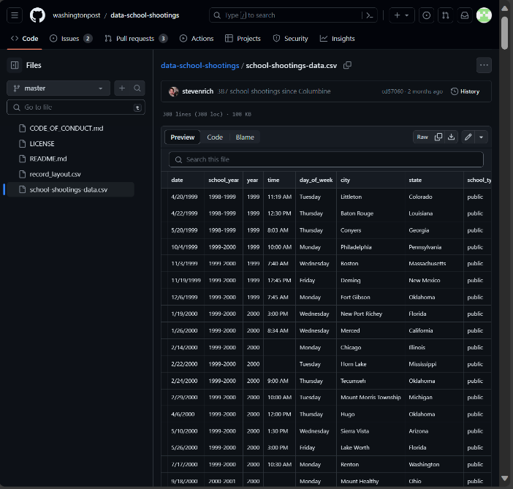2)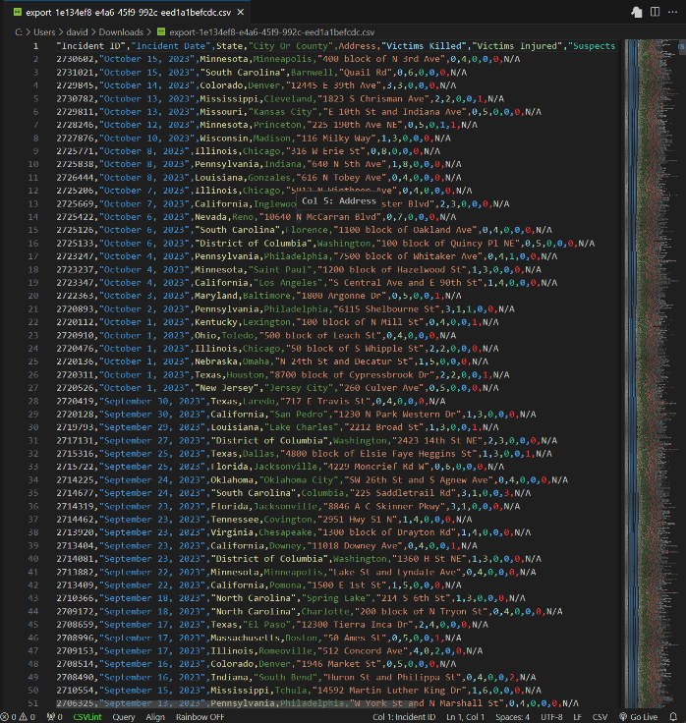

3)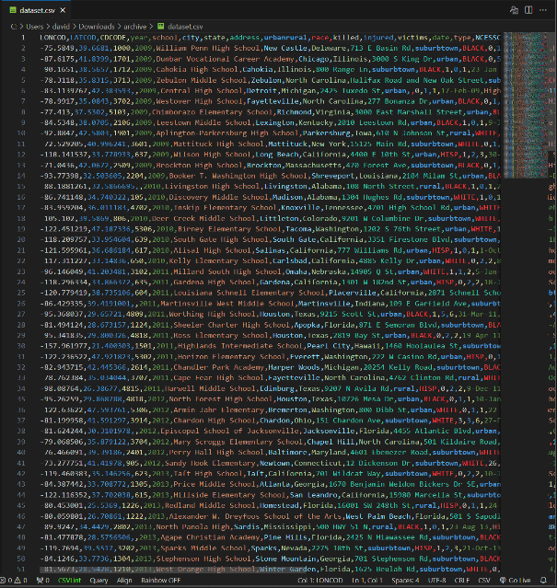 4)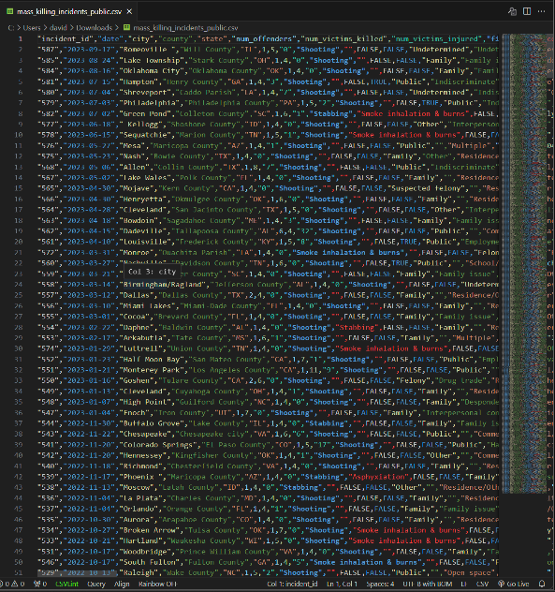

Inspirational Visualization:

[Data Visualizations |

[Analysis of School Shootings in the U.S. | Kaggle](https://www.kaggle.com/code/sahebategally/analysis-of-school-shootings-in-the-u-s)

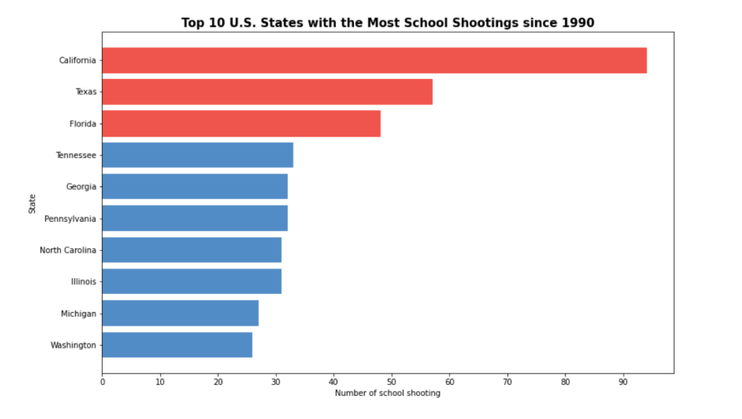

Sketch of Final Design:

Display Data

Merge Data

Extract Data

GitHub Repo: [arc71080/group_project_3 (github.com)](https://github.com/arc71080/group_project_3)